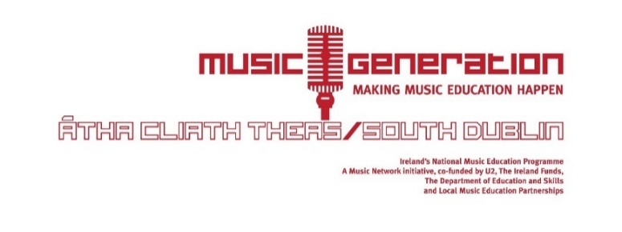
Expression of Interest Form
Choose a Hub Location:
- Clondalkin (St Peter Apostles JNS, Neilstown, Clondalkin, WEDNESDAYS)
- Rathcoole (Rathcoole Community Centre, THURSDAYS)

Students Name: __________________________ Age: ___________
Parent/Guardian Name&Telephone: ________________________________
Email: __________________________________________________
Which instrument is your child interested in learning?
- Musical Theatre (Vocal mixed with drama. Songs from Musicals)
- Vocal
- Keyboard (Duo or Individual classes only)
- Violin/Fiddle
- Cello (Clondalkin Only)
- Guitar
- Ukulele
- Drumming
- VIVO Music (Age 7 – 8 yrs, singing, movement, percussion. This class gives children a chance to choose what instrument they would like to take up while learning the fundamentals of music which are skills needed when learning any instrument)

- Concertina (Rathcoole only)
- Tin Whistle (Rathcoole only)
- Trad Ensemble (Rathcoole only)
- MGSD County Trad Ensemble (Open to children learning trad music throughout the county. Email info@musicgenerationsouthdublin.ie for further info.)
Lesson type:
- Group €160 (3 – 6 students in the class)
- Duo €190 (2 students in the class)
- Individual €390 (one to one lesson)
Fees are based on 30 weeks of lessons, Sept 2018 – May 2019.

Previous Experience in chosen instrument: YES NO
Instrument Rental: YES NO (violins, guitars, concertinas, cellos, keyboards €30 fee for 30 weeks of rental)

Specify any time which does not suit for lesson on the Hub day? ___________ ______________________________________________
Please return your form to info@musicgenerationsouthdublin.ie

